December monthly report
Sothearoth Heng
NCR ID: 803198
Under the supervision of
Dr. Pongkarn Chakthranont
Contract Number: NCR-NN-2023-20170-EN
December 2023
Project Title:
Development of Cu-based catalyst for electrochemical CO₂ reduction to C₂ products: combined computational chemistry and electrochemical engineering approach
Checked by:
...........................................................
Dr. Pongkarn Chakthranont

- Tasks list for December
- Literature Review on synthesis of Ag NPs and NH₂-Ag NPs through different methods
- Experimental design, synthesis, and characterization of silver nanoparticles
- Investigation of CO₂RR performance in a zero-gap electrolyzer using different types of membrane (Bipolar, Fumasep AEM, and Sustainion AEM)
- Investigation of CO₂RR performance in a zero-gap electrolyzer using a sputtered Ag cathode electrode
- Experimental
Synthesis of Ag NPs via chemical reduction method
Briefly, 3.82 g of AgNO₃ precursor was thoroughly dissolved in 300 ml of DI water to make 75mM AgNO₃ solution. NaBH₄ was used as a reducing agent. 0.94 g of NaBH₄ was carefully dissolved in 300 ml of cold DI water under 0°C ice bath and stirring rate of 500 rpm. Afterwards, the AgNO₃ solution was slowly dropped into NaBH₄ with a flow rate of 10 ml/min, and then a transparent solution turned into black color, indicating the formation of Ag NPs. After completely adding AgNO₃ solution, the mixture solution was further stirred at 500rpm for another hour to complete the reaction. The precipitated Ag product was filtrated and washed by DI and EtOH for several time and followed by drying under 60°C for 6h. The obtained Ag NPs was further characterized by FESEM.
Synthesis of NH₂-Ag NPs
The amino functionalized silver nanoparticles catalyst (NH₂-Ag NPs) was prepared by a hydrothermal method.¹⁸ Initially, 16.4 mg of NaCl and 1.34 PVP (MW = 55000) were dissolved and vigorously stirred in 20 ml of ethylene glycol (EG) to make a transparent solution (denoted as solution A). 0.69 g of AgNO₃ was dissolved in 10 ml of EG to make a silver solution, (denoted as solution B). 31.1 mg of butylamine (BNH₂) was also dissolved in 10ml of EG to obtain a functionalized-ligand solution (denoted as solution C). Afterwards, solution B and C was slowly added to solution A under stirring. 8 ml of glycerol was then added into the above mixture solution to form a colloidal solution. Next, the colloidal solution was transferred to a 100 ml Teflon-lined stainless autoclave and heated in an oven at 160°C for 2h. Finally, the precipitated NH₂-Ag NPs product was centrifuged, washed with EtOH for several time, and overnight dried under 40°C in vacuum oven. The obtained NH₂-Ag NPs was further characterized FESEM.
Experiment conditions
30ml of 1M KOH anolyte was recirculated into the anodic compartment with a flow rate of 30rpm by a peristatic pump. The cathodic flow field was fed by 30 ml/min of a humidified pure CO₂ under room temperature.
Study of different types of membranes: NiFe and commercial Ag were used as anode and cathode electrodes, while different membranes, such as fumasep Bipolar, AEM and Sustainion AEM were used in this section.

- Result
Characterization of as-prepared Ag NPs samples
As can be seen in Fig. 1, the size of Ag nanoparticles obtained from a chemical reduction method was approximately 900nm with a random particle size distribution. These results might be caused from rapid adding of AgNO₃ solution into NaBH₄ (10ml/min), unconcerned rising of ice bath temperature, and short reaction time.

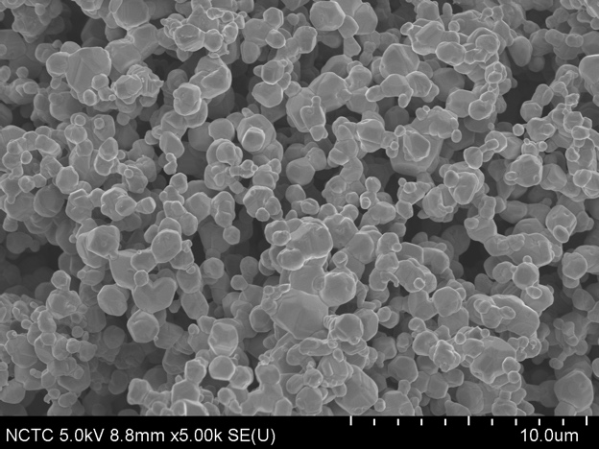
Figure 1. FE-SEM of as-prepared Ag NPs

Based on FE-SEM images, impurities and different morphologies with cubic and rod shapes was observed in the as-prepared catalyst surface, which might result from short mixing time, reaction time, and centrifugation time. Therefore, increasing all these parameters would prolongate the particles to gently grow into a unique shape with less impurity rather than aggregating with a random morphology.
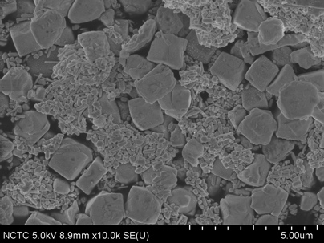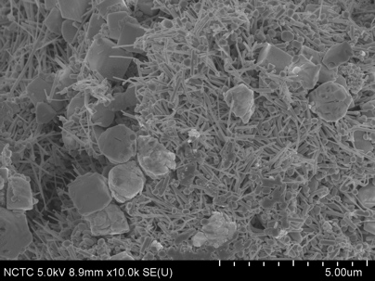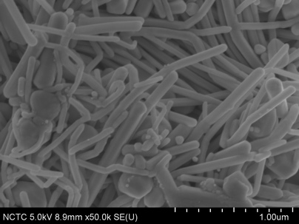
Figure 2. FE-SEM of as-prepared NH₂-Ag NPs

440 nm of the sputtered Ag layer appearing above the carbon layer was obtained after sputtering for 15min.
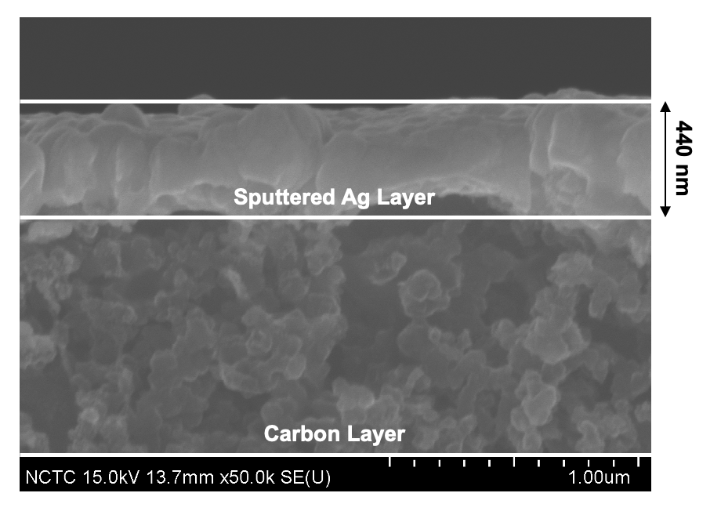
Figure 3. FE-SEM side view image of a sputtered Ag.

The Ag layer of a commercial Ag as shown in Fig. 4 was approximately 6.4 µm.
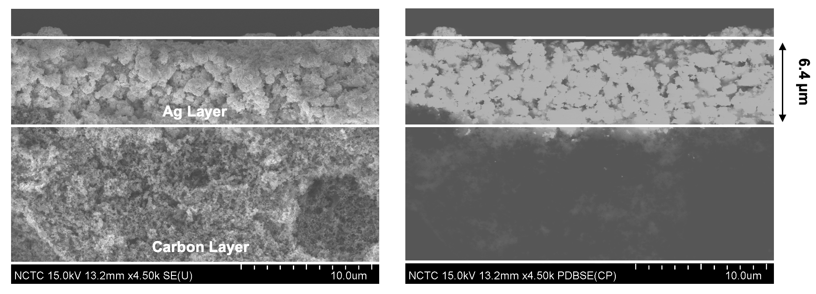
Figure 4. FE-SEM side view image of a commercial Ag

Electrochemical CO₂ reduction performance with different membranes

According to Fig. 5, a MEA cell configuration with a Bipolar membrane (BPM) showed high HER selectivity and FE(H₂) of approx. 50-60%, and by replacing a bipolar membrane with sustainion AEM, the FE(CO) was highly increased to 65% with a very low competing reaction (HER). Similar results to our case were also encountered.^{12,13} In BPM-MEA system, the local pH of cathode compartment becomes more acidic due to high H⁺ ion concentration, which is not productive in the CO₂RR performance, but highly productive in the HER, leading to HER dominates in the system.^{14,15} On the other hands, the AEM-MEA system highly performed CO₂RR to CO product at 50 mA/cm². However, the total faradaic efficiency was still less than 100%, and according to other reports, this could result from the formation of another byproduct, likely to be HCOO⁻ besides CO and H₂.¹⁶ Based on the aforementioned, AEM-MEA system seems to be more reasonable for electrochemical CO₂RR in AEM-MEA system than BPM and Fumasep AEM (the results did not show due to it was impossible to operate) systems, even though there is a tradeoff regarding the CO₂ crossover to anodic compartment (massive loss) during the operation.
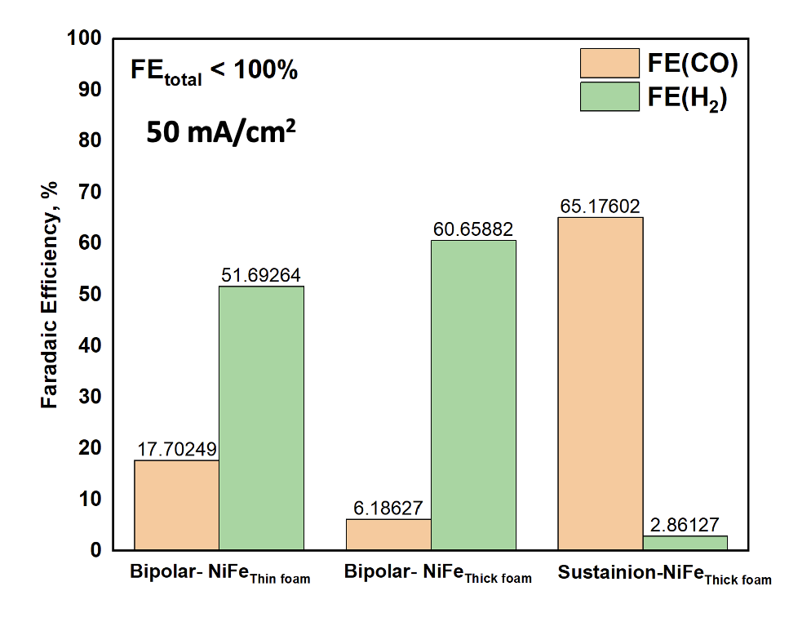
Figure 5. Faradaic Efficiency of difference cell configurations under applied j of 50 mA/cm²

Electrochemical CO₂ reduction performance with a sputtered Ag cathode

A CO₂RR performance was conducted with a cell configuration as NiFe/AEM_{Sust}/Ag_{sput} under applied current density (j) range of 50-200 mA/cm². The maximum FE(CO) was obtained under j of 100-150mA/cm² with %FE(H₂) approx. 8-12%, while the FE(CO) at the lowest (50 mA/cm²) and highest j (200 mA/cm²) was approx. 60-64%. These results showing that the sputtered Ag cathode catalyst with a Ag layer of 440 nm exhibited similar performance to the previous experiment with a commercial Ag cathode. In order to optimize the eCO₂RR performance with the use of sputtered Ag cathode, the investigation of the sputtering time and thickness of Ag layer should also be address. Besides the what we have reported, we also observed the NiCO₃ formation on the NiFe anode resulting from the interaction between crossover carbonate and bicarbonate ions and Ni ions, which subsequently caused the anode degradation and Ni poisoning on Ag layer.¹⁷ Therefore, either an alternative anode should be considered or replacing the KHCO₃ anolyte with KOH solution at a high flow rate could mitigate a drop in anolyte pH.

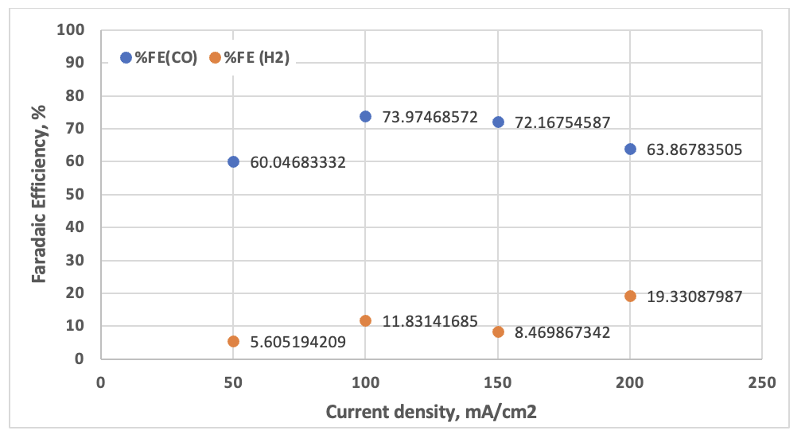

Figure 6. Faradaic efficiency of eCO₂RR performance with a sputtered Ag cathode under 50-200 mA/cm²

- Summary
In summary, Ag NPs and NH₂-Ag NPs cathode catalysts were successfully prepared under chemical reduction and hydrothermal methods, respectively. A spherical Ag particle size was largely around 900 nm. NH₂-Ag NPs exhibited uncertain morphologies (cubic and rod shape) along with impurities, thereby optimizing the synthesis parameters should be considered in the next batch. A sputtered Ag cathode with a Ag thickness of 440nm showed similar performance to commercial Ag cathode catalyst with a maximum FE(CO) of 74%. AEM-MEA system was the best systems for CO₂RR to CO product with massive CO₂ loss to the anode side, while BPM system struggling with the suppression of CO₂RR under an acidic environment. Electrodes degradation by the formation of NiCO₃ and Ni²⁺ crossover becomes a challenge problem in a zero-gap electrolyzer system, thus either alternative anodes or replacing the KHCO₃ with KOH anolyte should be considered.

- Upcoming Tasks
- Synthesis of Ag-NPs and NH₂-Ag NPs catalysts by controlling parameters
- Spray coating as-prepared catalysts on carbon paper for further use as cathode materials
- CO₂RR performance test in a zero-gap electrolyzer with a cell configuration IrO₂/AEM_{Sustaionion}/Ag or NiFe/AEM_{sustainion}/Ag with KOH anolyte

- Reference
12. Kailun Yang, Mengran Li, Siddhartha Subramanian, Marijn A. Blommaert, Wilson A. Smith, and Thomas Burdyny. ACS Energy Letters 2021 6 (12), 4291-4298.
13. Colin P. O’Brien, Rui Kai Miao, Shijie Liu, Yi Xu, Geonhui Lee, Anthony Robb, Jianan Erick Huang, Ke Xie, Koen Bertens, Christine M. Gabardo, Jonathan P. Edwards, Cao-Thang Dinh, Edward H. Sargent, and David Sinton. ACS Energy Letters 2021 6 (8), 2952-2959
14. Li, Yuguang C.; Zhou, Dekai; Yan, Zhifei; Goncalves, Ricardo H.; Salvatore, Danielle A.; Berlinguette, Curtis P.; Mallouk, Thomas E. ACS Energy Letters (2016), 1 (6), 1149-1153
15. Danielle A. Salvatore, David M. Weekes, Jingfu He, Kevan E. Dettelbach, Yuguang C. Li, Thomas E. Mallouk, and Curtis P. Berlinguette. ACS Energy Letters 2018 3 (1), 149-154
16. Gastón O. Larrazábal, Patrick Strøm-Hansen, Jens P. Heli, Kevin Zeiter, Kasper T. Therkildsen, Ib Chorkendorff, and Brian Seger. ACS Applied Materials & Interfaces 2019 11 (44), 41281-41288
17. Ádám Vass, Balázs Endrődi, Gergely Ferenc Samu, Ádám Balog, Attila Kormányos, Serhiy Cherevko, and Csaba Janáky. ACS Energy Letters 2021 6 (11), 3801-3808
18. Liu, Z., Yan, T., Shi, H., Pan, H., & Kang, P. (2024). Grafting amine-functionalized ligand layer on catalyst for electrochemical CO2 capture and utilization. Applied Catalysis B: Environmental, 343, 123456.

